Extensibility

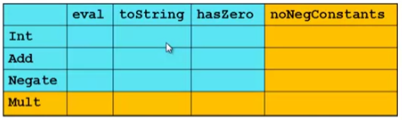

* For implementing our grid so far, SML/Racket style usually by column and Ruby/Java style usually by row
* But beyond just style, this decision affects what (unexpected?) software *extensions* need not change old code
* Functions [see ML code]:
  + Easy to add a **new operation**, e.g., NoNegConstants
  + Adding a **new variant/type**, e.g., Mult **requires modifying ALL old functions**, but ML type-checker gives a to-do list if original code avoided wildcard patterns
* Objects [see Ruby code]:
  + Easy to add a **new variant**, e.g., Mult
  + Adding a **new operation**, e.g., NoNegConstants requires modifying old classes, but Java type-checker gives a to-do list if original code avoided default methods

The other way is possible

* Functions allow new operations and objects allow new variants without modifying existing code even if they didn’t plan for it
  + Natural result of decomposition

Optional:

* Functions can support new variants somewhat awkwardly “if they plan ahead”
  + Not explained here: can use type constructors to make datatypes extensible and have operations take function arguments to give results for the extensions
* Objects can support new operations somewhat awkwardly “if they plan ahead”
  + Not explained here: The popular Visitor Pattern uses the double-dispatch pattern to allow new operations “on the side”

Thoughts on Extensibility

* Making software extensible is valuable and hard
  + If you know you want new operations, use FP
  + If you know you want new variants, use OOP
  + If both? Languages like Scala try; it’s a hard problem
  + Reality: The future is often hard to predict!
* Extensibility is a double-edged sword
  + Code more reusable without being changed later
  + But makes original code more difficult to reason about locally or change later (could break extensions)
  + Often language mechanisms to make code *less* extensible (ML modules *hide* datatypes; Java’s *final* prevents subclassing/overriding)